**STOCK PREDICTION USING MACHINE LEARNING**

**A PROJECT REPORT**

***Submitted By***

|  |  |
| --- | --- |
| **BHARANIDHARAN** | **(31012120503)** |

***In partial fulfillment for the award of the degree Of***

**BACHELOR OF TECHNOLOGY**

***In***

**INFORMATION TECHNOLOGY**

**ANAND INSTITUTE OF HIGHER TECHNOLOGY**



# ANNA UNIVERSITY::CHENNAI 600 025

**NOV-2024**

**ANNA UNIVERSITY::CHENNAI 600 025**

**BONAFIDE CERTIFICATE**

Certified that this project report **“STOCK PREDICTION USING MACHINE LEARNING”** is the bonafide work of **“BHARANIDHARAN S (310121205003) ”** who carried out the project work under my supervision.

**SIGNATURE SIGNATURE**

## Dr.K.Karnavel, M.Tech., Ph.D., Mr.M.Manikandan M.E.,

## 

**SUPERVISOR**

**HEAD OF THE DEPARTMENT ASSISTANT PROFESSOR**

Department of Information Technology Department of Information

Technology

Anand Institute of Higher Technology, Anand Institute of Higher Technology, Kazhipattur, Kazhipattur,

Chennai-603103. Chennai-603103.

Submitted to Project and Viva Voce Examination held on

**INTERNAL EXAMINER EXTERNAL EXAMINER**

# ACKNOWLEDGEMENT

First and foremost, we thank the almighty for showering his abundant blessings onus to successfully complete the project. Our sincere thanks to, our beloved **“Kalvivallal” Late Thiru T. Kalasalingam, B.Com., Founder** for his keen interest and affection towards us.

Our sincere thanks and gratitude to our **SevaRatna Dr. K.Sridharan,M.Com., MBA., Ph.D., Chairman, Dr. S. Arivazhagi, M.B.B.S., Secretary** for giving us the necessary support during the project work. We convey our thanks to our **Dr.K.Karnavel, M.Tech., Ph.D., Principal** for his support towards the successful completion of this project.

We pay our grateful acknowledgement and sincere thanks to **Assistant Professor N.Manikandan, M.E.,IT** for the good coordinating and for better guidance and constant encouragement in completing this project to make it successful one.

We thank entire **Staff Members** of our department and **ARUL TECHNOLOGIES** for helping us by providing valuable suggestions and timely ideas for successful completion of the project.

Last but not the least our **Family Members and Friends** have been a great source of inspiration and strength to us during the course of this project work and our sincere thanks to them.

# ABSTRACT

This report outlines the development and evaluation of a machine learning-based stock price prediction model, with the aim of providing insights into future stock trends and enhancing investment strategies. The volatility and unpredictability of financial markets make stock price prediction an immensely challenging problem, demanding approaches that can process large, dynamic data sets and account for a wide variety of external factors. To address these complexities, this project leverages supervised machine learning techniques, exploring algorithms such as Linear Regression, and Long Short-Term Memory (LSTM) neural networks to predict future stock prices based on historical market data.

In this project, historical price data, including daily open, close, high, low prices, and trading volume, is collected from public stock exchanges and cleaned for accurate analysis. Additionally, external macroeconomic factors, such as interest rates, inflation data, and global news sentiment, are incorporated as auxiliary features to enhance prediction accuracy. The processed data is then split into training and testing sets, and feature engineering techniques are applied to capture time-series dependencies and trends

The findings from this project suggest that, while traditional models offer faster computation and simpler interpretability, the LSTM model demonstrates superior performance in capturing the non-linear, temporal dependencies of stock price data. The report concludes with recommendations for deploying machine learning models in live trading environments and suggests future research directions, including incorporating alternative data sources (such as social media sentiment and news analytics) and exploring advanced techniques like reinforcement learning for adaptive trading strategies. This project aims to contribute to the growing field of financial technology, demonstrating the potential of machine learning as a tool for enhancing decision-making in stock market investments.

This report discusses the strengths, limitations, and computational efficiency of each algorithm, providing a comparative analysis of traditional machine learning approaches versus deep learning methods in stock prediction.

# Table of Contents

## INTRODUCTION

1. **REQUIREMENT SPECIFICATION**

## DESIGN

1. **CODING**

## TESTING

1. **INSTALLATION INSTRUCTION**

## END-USER INSTRUCTION

1. **FUTURE WORK & IMAGES**

## SUMMARY

1. **REFERENCE**

## CHAPTER-1

**INTRODUCTION**

With the rapid growth of global financial markets and the increasing accessibility of trading platforms, there is a rising demand for tools that can predict stock price trends and assist investors in making informed decisions. Stock markets are characterized by high volatility and complexity, influenced by a wide array of factors, including economic indicators, corporate performance, geopolitical events, and even social sentiment. Stock prediction models typically utilize a range of supervised learning techniques, such as Linear Regression, Decision Trees, and Support Vector Machines (SVMs), along with advanced neural network architectures like Long Short-Term Memory (LSTM) networks.

Machine learning, a subset of artificial intelligence, has emerged as a powerful solution in addressing the challenges of stock price prediction. By leveraging vast historical datasets, machine learning algorithms can identify patterns and trends that are not immediately evident to human analysts. Machine learning models can incorporate and process various data types, including time-series stock prices, trading volumes, news sentiment, and other macroeconomic variables, providing a comprehensive approach to understanding and forecasting stock movements. This capability is invaluable for financial analysts, investors, and portfolio managers seeking to mitigate risks and maximize returns in a competitive environment.

The primary goal of stock prediction using machine learning is not only to anticipate the next price movement but also to gain insights into market behavior and provide a probabilistic forecast of future trends. In this study, we aim to explore the application of various machine learning models to predict stock prices, evaluating their effectiveness and limitations. The research also addresses common challenges, such as dealing with volatile data, feature selection, and hyper parameter tuning, which are critical for improving model robustness and accuracy.

## CHAPTER-2

**REQUIREMENT SPECIFICATION**

This section outlines the requirements necessary for developing and deploying a stock prediction system using machine learning. The requirements are divided into functional and non-functional categories, addressing both the technical and performance considerations essential for an effective and scalable stock prediction system.

### Functional Requirements :-

**1) Data Collection:**

* The system must collect historical stock data, including daily opening price, closing price, high, low, and trading volume, from reliable financial data sources via APIs or data feeds.
* Macroeconomic indicators (e.g., interest rates, inflation data) and market sentiment data from news and social media must be integrated as additional features to improve model robustness.
* Data preprocessing steps must be implemented to handle noise, missing values, and irrelevant information, as well as to standardize data formats across different sources.

**2) Feature Engineering:**

* The system should generate relevant features such as moving averages, volatility indicators, and momentum scores from raw stock data to enhance predictive accuracy.
* Time-series-specific transformations should be performed, such as lagged data creation, to capture temporal dependencies.
* Sentiment analysis from news and social media sources should be included as a feature to capture market sentiment dynamics and improve the predictive power of the model

**3) Stock Price Prediction Models:**

* The system should support a variety of machine learning algorithms, such as Linear Regression, Support Vector Machines (SVMs), Decision Trees, and advanced models like Long Short-Term Memory (LSTM) neural networks.
* The system must be able to handle real-time data input, allowing for live or near-live prediction updates as new data becomes available.

**4) Model Evaluation and Optimization:**

* The system must evaluate model performance using appropriate metrics such as Mean Absolute Error (MAE), Mean Squared Error (MSE), and Root Mean Squared Error (RMSE).
* Hyper parameter tuning must be implemented to optimize model parameters for higher accuracy and better generalization.
* Back testing capabilities must be available to test the model on historical data and assess its performance under different market conditions.

**5) User Interface and Reporting:**

* The system should offer a user-friendly interface for financial analysts and traders to visualize prediction results, trends, and accuracy metrics.
* Users should be able to configure prediction intervals (e.g., daily, weekly, monthly) and customize model parameters based on their investment strategy.
* Automated reporting and notifications should be implemented to alert users of significant trend changes or predictions with high probability.

### Non-Functional Requirements:

### ****1) Scalability:****

* The system must be capable of scaling with large datasets, as the volume of historical and real-time data can grow significantly over time.
* The architecture should support distributed computing frameworks, allowing the model to be trained and updated efficiently on large financial datasets.
* Support large datasets and distributed computing for efficient processing

**2) Performance:**

* Predictions should be generated with low latency to ensure timely insights, especially in high-frequency trading scenarios.
* The system should be optimized to handle high-frequency data feeds without impacting prediction accuracy or response times.
* Ensure low-latency predictions for timely insights.

**3) Reliability and Availability:**

* The system should operate continuously with minimal downtime to ensure that it provides up-to-date predictions.
* Redundancy and failover mechanisms must be implemented to handle potential issues with data feeds or system components, ensuring uninterrupted data processing and prediction generation.
* Implement failover mechanisms for continuous operation and data processing

**4) Data Security and Privacy:**

* Sensitive financial data must be handled in compliance with industry regulations, employing data encryption and secure data storage practices.
* Access control mechanisms should be enforced to restrict unauthorized access to prediction models and financial data.
* Enforce encryption, secure storage, and access controls.

**5) Adaptability and Extensibility:**

* The system must be adaptable to incorporate new machine learning algorithms and alternative data sources as they become available.
* The architecture should support modular components, enabling easy integration of additional data types (e.g., sentiment from alternative sources or new technical indicators) without major overhauls to the system.
* Design modular components for easy integration of new data sources or models

## CHAPTER-3

## DESIGN

The design of a stock prediction system involves several key components that collect, preprocess, analyze, and visualize financial data to forecast stock trends. Following a modular approach, the system is flexible, scalable, and maintainable, supporting continuous updates to adapt to market changes. Below is a high-level design for the stock prediction system.

## System Architecture

The Stock Prediction system consists of the following core components:

* Data Collection Layer
* Preprocessing and Feature Extraction Layer
* Sentiment Classification Layer
* Results Storage and Visualization Layer
* Model Training and Update Module

### Components Design

**1. Data Collection Layer**

This layer is responsible for gathering stock market data and external factors relevant to stock prediction.

* **Financial Data Sources:** Collect historical stock prices (e.g., open, close, high, low, volume) via APIs from data providers like Yahoo Finance, Alpha Vantage, or Quandl.
* **External Data Sources:** Optionally integrate macroeconomic indicators (e.g., interest rates, inflation), as well as sentiment data from financial news and social media to capture market sentiment and broader economic context.

#### 2. ****Preprocessing and Feature Engineering Layer****

This layer ensures data is cleaned, structured, and transformed for accurate prediction modeling.

**A) Data Preprocessing Steps:**

* **Noise Removal:** Filter out irrelevant data, address missing values, and standardize formats.
* **Data Transformation:** Normalize or scale data to ensure consistency and improve model training.
* **Handling Temporal Aspects:** Create lagged features to capture dependencies over time (e.g., previous days’ prices).

**B) Feature Engineering:**

* **Technical Indicators:** Calculate features like moving averages, exponential moving averages, RSI (Relative Strength Index), and MACD (Moving Average Convergence Divergence).
* **Sentiment Analysis Features:** Use NLP techniques to analyze news or social media sentiment as an additional predictor of stock trends.
* **Time-Series Decomposition:** Decompose data into trend, seasonal, and residual components for a more comprehensive analysis of stock behavior.

#### 3. ****Prediction Model Layer****

This layer consists of machine learning and deep learning models used to predict stock prices based on engineered features.

**Machine Learning Models:** Initial models include Linear Regression, Decision Trees, and Support Vector Machines (SVM) for faster testing and initial validation.

**Deep Learning Models:**

* **RNN/LSTM:** Recurrent Neural Networks and Long Short-Term Memory networks to capture temporal dependencies and trends in sequential stock data.
* **Transformer Models:** Time-series-adapted transformers (such as TCNs or temporal BERT models) for more advanced, context-aware predictions in dynamic markets.

**Multi-Period Forecasting:** Models should provide both short-term and long-term predictions based on investor requirements.

#### 4. ****Results Storage and Visualization Layer****

This layer handles data storage and provides a dashboard for visualizing predictions and performance metrics.

* **Database:**

Store predictions, performance metrics, and metadata (e.g., stock symbols, prediction dates, accuracy scores).

* **Visualization Dashboard:**
* **Price Prediction Trends:** Display forecasts for individual stocks over specified time periods.
* **Technical Indicator Analysis:** Visualize key technical indicators like moving averages and volume changes.
* **Sentiment Analysis Overlay:** Include sentiment trends from news or social media to show potential correlations with stock performance

.

* **Performance Metrics:** Show model performance metrics like accuracy, MSE, and RMSE over time.

#### 5. ****Model Training and Update Module****

This module manages model training and updates to ensure the system adapts to new data patterns and market dynamics.

**1) Initial Model Training:**

Train models on historical stock data, tuning them using cross-validation and metrics like MAE, MSE, and RMSE.

**2) Continuous Model Update:**

* Periodically retrain models on new data to capture recent market trends and adapt to changing conditions (e.g., new events, shifts in market sentiment).

Set up an automated retraining pipeline for regular updates

**3) Monitoring:**

* Track model performance on live data to detect potential accuracy declines or “drift” due to market shifts.

### Data Flow in the Stock Prediction System:

* **Data Collection**: Stock data, market indicators, and (optionally) sentiment data are collected and sent to the preprocessing layer.
* **Preprocessing**: The data is cleaned, normalized, and split into segments. Features like moving averages, RSI, and sentiment scores are extracted to form feature vectors.
* **Prediction**: Feature vectors are input into machine learning models (e.g., LSTM, CNN) for prediction. The output is the forecasted stock price or trend direction.
* **Results Storage and Visualization**: Predicted results are stored in a database and visualized in real time on the dashboard, showing trends and forecast accuracy.

### Component Design

#### 1) Data Collection Layer:

* **APIs and Data Sources**: Financial APIs, news sentiment API (optional).
* **Data Format**: CSV files or JSON format from API responses.

#### 2) Preprocessing and Feature Engineering Layer:

* **Noise Filtering**: Outlier removal or smoothing techniques to handle stock price spikes or drops.
* **Segmentation**: Sliding window approach for creating rolling time segments (e.g., using the past 60 days to predict the next day).
* **Feature Extraction**: Key market indicators and price trends as features.

#### 3) Prediction and Classification Models:

* **LSTM Model**: Learns temporal dependencies and market patterns over time, such as seasonal trends or recent price directions.
* **CNN Model**: Identifies local patterns in time-series data, improving the detection of short-term price patterns.

#### 4)Output Layer:

* **Softmax or Regression Output**: Softmax for categorical predictions (up/down trend) or a regression layer for price prediction.

### 

### Technology Stack

#### 1)Data Collection:

* **APIs**: Alpha Vantage, Yahoo Finance.
* **Programming Language**: Python.

#### 2)Preprocessing and Feature Engineering:

* **Libraries**: Pandas, NumPy, SciPy, and Scikit-learn

.

#### 3)Prediction Models:

* **Frameworks**: TensorFlow, Keras, PyTorch.
* **Algorithms**: LSTM, CNN, and hybrid models.

#### 4)Visualization and Storage:

* **Database**: SQL or NoSQL (e.g., MySQL, PostgreSQL).
* **Visualization Tools**: Matplotlib, Plotly, Seaborn, and Dash (for interactive dashboards)

.

#### 5)Deployment:

* **Platform**: Google Collaborator, AWS, or Microsoft Azure.

### Conclusion

The Stock Prediction System uses deep learning to predict stock prices by analyzing historical data, technical indicators, and, optionally, sentiment data. This modular system is designed for scalability and adaptability in the volatile stock market environment. The use of models like LSTM and CNN ensures the system can capture both long-term trends and short-term patterns for more accurate forecasting, making it valuable for applications in finance and trading.

## CHAPTER-4 CODING

**import pandas as pd import numpy as np**

**import matplotlib.pyplot as plt**

**%matplotlib inline import seaborn as sns**

**import nltk**

**from nltk.corpus import stopwords**

**from nltk.classify import SklearnClassifier**

**from wordcloud import WordCloud,STOPWORDS import matplotlib.pyplot as plt**

**%matplotlib inline**

**from subprocess import check_output**

**from sklearn.feature_extraction.text import CountVectorizer from keras.preprocessing.text import Tokenizer**

**from keras.preprocessing.sequence import pad_sequences from keras.models import Sequential**

**from keras.layers import Dense, Embedding, LSTM, SpatialDropout1D from sklearn.model_selection import train_test_split**

**from keras.utils.np_utils import to_categorical import re**

**train = pd.read_csv("C:/train_data.csv") test = pd.read_csv("C:/test_data.csv")**

**train.head() test.head() train.count()**

**test.count() train.duplicated().sum()**

**train = train.drop_duplicates().reset_index(drop=True) train.info()**

**train.dtypes train.describe()**

**sns.countplot(y=train.sentiment); sns.countplot( train['sentiment']); train.sentiment.value_counts() train.isnull().sum() test.isnull().sum()**

**train.columns**

**train.rename(columns = {'reviews.text':'reviews_text', 'reviews.title':'reviews_title','reviews.date':'reviews_date'}, inplace = True)**

**train.columns train['sentiment'].value_counts().plot(kind='pie', autopct= '%1.0f%%')**

**train = train[train.sentiment != "Neutral"] train_pos = train[ train['sentiment'] == 'Positive'] train_pos = train_pos['reviews_text']**

**train_neg = train[ train['sentiment'] == 'Negative'] train_neg = train_neg['reviews_text']**

**def wordcloud_draw(data, color = 'black'):**

**words = ' '.join(data)**

**cleaned_word = " ".join([word for word in words.split()**

**if 'http' not in word**

**and not word.startswith('@')**

**and not word.startswith('#')**

**and word != 'RT'**

**])**

**wordcloud = WordCloud(stopwords=STOPWORDS,**

**background_color=color,**

**width=2500,**

**height=2000**

**).generate(cleaned_word)**

**plt.figure(1,figsize=(13, 13))**

**plt.imshow(wordcloud)**

**plt.axis('off')**

**plt.show()**

**print("Positive words") wordcloud_draw(train_pos,'white') print("Negative words") wordcloud_draw(train_neg)**

**def remove_non_ascii(words):**

**new_words = []**

**for word in words:**

**new_word = unicodedata.normalize('NFKD', word).encode('ascii', 'ignore').decode('utf-8', 'ignore')**

**new_words.append(new_word)**

**return new_words**

**def to_lowercase(words):**

**new_words = []**

**for word in words:**

**new_word = word.lower()**

**new_words.append(new_word)**

**return new_words**

**def remove_punctuation(words):**

**new_words = []**

**for word in words:**

**new_word = re.sub(r'[^\w\s]', '', word)**

**if new_word != '':**

**new_words.append(new_word)**

**return new_words**

**def remove_numbers(words):**

**new_words = []**

**for word in words:**

**new_word = re.sub("\d+", "", word)**

**if new_word != '':**

**new_words.append(new_word)**

**return new_words**

**def remove_stopwords(words):**

**new_words = []**

**for word in words:**

**if word not in stopwords.words('english'):**

**new_words.append(word)**

**return new_words**

**def stem_words(words):**

**stemmer = LancasterStemmer()**

**stems = []**

**for word in words:**

**stem = stemmer.stem(word)**

**stems.append(stem)**

**return stems**

**def lemmatize_verbs(words):**

**lemmatizer = WordNetLemmatizer()**

**lemmas = []**

**for word in words:**

**lemma = lemmatizer.lemmatize(word, pos='v')**

**lemmas.append(lemma)**

**return lemmas**

**def normalize(words):**

**words = remove_non_ascii(words)**

**words = to_lowercase(words)**

**words = remove_punctuation(words)**

**words = remove_numbers(words)**

***# words = remove_stopwords(words)***

**return words**

***# First step - tokenizing phrases* train['reviews_text'] = train['reviews_text'].apply(nltk.word_tokenize)**

***#train['reviews_text'] = train['reviews_text'].apply(normalize)***

**train['reviews_text'].head()**

## CHAPTER-5 TESTING

To ensure the effectiveness and reliability of the stock prediction system, a comprehensive testing process is conducted. This ensures that all components function correctly and meet performance expectations while providing accurate and actionable predictions. The testing strategy is divided into several stages: unit testing, integration testing, performance testing, and more.

### 1. ****Unit Testing****

**Objective:** Validate individual modules of the stock prediction system.

**Components Tested:**

* **Data Collection:** Ensure the system correctly retrieves stock data from APIs, financial databases, and historical records.
* **Data Preprocessing:** Test preprocessing steps such as handling missing values, scaling numerical data, and managing outliers.
* **Feature Engineering:** Validate the creation of technical indicators (e.g., moving averages, RSI, MACD) and time-series features.
* **Model Training and Prediction:** Verify that models like Linear Regression, LSTM, or ARIMA produce outputs without errors.

**Edge Case Handling:**

* Non-trading days or missing data points.
* Sudden market anomalies (e.g., "flash crashes").
* Incorporating news or events with sparse historical data.

### 2. ****Integration Testing****

**Objective:** Ensure seamless interaction between system components.

* **Tests Conducted:**
* Verify that data flows correctly from collection to preprocessing, feature engineering, model training, and prediction.
* Validate the integration of external modules, such as APIs for live stock prices or news sentiment analysis, into the prediction workflow.
* Test end-to-end data pipelines to ensure no data loss or corruption occurs.

### 3. ****Performance Testing****

**Objective:** Measure system efficiency and scalability

.

**Metrics Evaluated:**

* Response time for real-time predictions during market hours.
* Speed of batch processing for large historical datasets.

### 4. ****Accuracy Testing****

**Objective:** Evaluate model performance and predictive accuracy.

**Tests Conducted:**

* Use metrics like Mean Absolute Error (MAE), Root Mean Squared Error (RMSE), and R-squared to evaluate predictions.
* Test on labeled datasets with known outcomes for validation.
* Assess performance on edge cases such as highly volatile stocks or sectors impacted by macroeconomic events.

### 5. ****Stress Testing****

**Objective:** Simulate extreme conditions to ensure reliability under load.

**Scenarios Simulated:**

* High-frequency trading simulations with continuous data updates.
* Sudden spikes in data inputs due to unexpected market events.
* Prolonged stress scenarios with intensive computation requirements.

### 6. ****User Acceptance Testing (UAT)****

**Objective:** Confirm that the system meets business objectives.

* **Tests Conducted:**
* Ensure predictions are presented in user-friendly dashboards with actionable insights (e.g., buy/sell recommendations, risk assessments).
* Validate the clarity and utility of visualizations like trend analysis, stock performance charts, and portfolio optimization suggestions.

### 7. ****Model Update and Retraining Testing****

**Objective:** Maintain accuracy and adapt to market changes.

* **Tests Conducted:**
* Validate that retraining the model with new market data improves accuracy without disrupting live operations.
* Ensure smooth transitions between old and updated models in real-time predictions.
* Test for model drift to monitor and mitigate prediction degradation over time.

### 8. ****Security and Privacy Testing****

**Objective:** Ensure data protection and compliance with regulations.

* **Tests Conducted:**
* Verify secure handling and encryption of sensitive financial data.
* Ensure compliance with standards like GDPR and PCI DSS.
* Test access controls to prevent unauthorized access to prediction models or financial datasets.

### Conclusion:

Through rigorous testing across all components, the stock prediction system is optimized for accuracy, reliability, and scalability. Each phase ensures that the system aligns with business goals and delivers robust predictions under diverse conditions. By adhering to this structured testing framework, the system can provide actionable insights, helping users make informed financial decisions.

## CHAPTER-6

**INSTALLATION INSTRUCTION**

1. **Set Up Development Environment:**  
   Begin by ensuring Python is installed on your system (version 3.8 or higher). Create a virtual environment to isolate project dependencies. This will help manage libraries and avoid conflicts with other Python projects.
2. **Install Required Libraries:**  
   Install the necessary libraries for data handling, visualization, machine learning, and feature engineering. This includes libraries like pandas, NumPy, matplotlib, sea born, scikit-learn, Tensor Flow or PyTorch, yfinance, ta (for technical indicators), and pytrends. Additionally, install libraries to handle API requests and data retrieval.
3. **Configure Data Sources:**  
   Set up access to financial data providers such as Yahoo Finance, Alpha Vantage, or Quandl. Register and obtain an API key. Save the key in a configuration file to allow the system to retrieve stock data securely. If you plan to store or retrieve historical data using a database, configure database connectors and connection details accordingly.
4. **Set Up Visualization Tools:**  
   Install and configure tools for creating dashboards and visualizations. Use libraries like Dash and Plotly for Python-based visualizations, or set up export functionality for use with external tools like Tableau or Power BI.
5. **Test the System:**  
   Run sample stock data through the entire pipeline to verify data flow, feature engineering, and model predictions. Ensure the system functions correctly and validate its outputs using historical trends and performance metrics.

.

## CHAPTER-7

**END-USER INSTRUCTION**

The stock prediction system is designed to provide actionable insights into market trends, stock performance, and potential investment opportunities based on machine learning models.

**1) Access the Dashboard:**  
 Log in to the stock prediction platform using your credentials. The dashboard serves as the central hub for accessing stock forecasts, market trends, and performance visualizations.

**2) Stock Prediction View:**

* **Market Overview:**  
  On the main page, view an overview of market trends, including graphs and charts representing historical stock prices and predicted future values. Key performance metrics such as percentage growth or decline and volatility indices will also be displayed.
* **Stock-Specific Forecasts:**  
  Navigate to specific stocks to access detailed predictions. For each stock, the system will display forecasted trends, technical indicators (e.g., moving averages, RSI, and MACD), and predictions for short-term or long-term performance.

**3) Filter and Search Stocks:**

* Use filters to search for specific stocks, sectors, or time periods (e.g., last 6 months or next 30 days). This allows users to analyze specific stocks or portfolios within defined time frames.
* Search for keywords like “tech sector” or “high growth” to focus on relevant stocks or categories.

**4) Export Data:**

* If you need to share insights or reports, the system allows you to export predictions, charts, and data visualizations. Use the “Export” button on the dashboard to download reports in formats like PDF, CSV, or Excel for easy sharing.

**5) Real-Time Monitoring:**

* The system updates in real-time with live stock market data. You can monitor the latest predictions and market movements as they happen, ensuring timely and informed decision-making.

**6) Risk and Performance Analysis:**

* Check risk scores for individual stocks or portfolios, helping you assess potential investment risks.
* View detailed performance analysis that includes historical vs. predicted accuracy rates, ensuring the reliability of the predictions.

**7) Portfolio Recommendations:**

* The system offers portfolio recommendations based on machine learning predictions and market data. Suggestions include optimal stock allocations and diversification strategies tailored to user-defined risk preferences and investment goals.

## CHAPTER-8

## FUTURE WORK & IMAGES

Future work for the stock prediction system will primarily focus on improving its predictive accuracy by incorporating more advanced machine learning models. This includes adopting GPT-based architectures and transformers, which are capable of capturing intricate patterns in stock prices and identifying complex market trends. By using these sophisticated models, the system will be able to provide more accurate and robust predictions, even in volatile market conditions.

To ensure the system remains responsive to evolving market dynamics, real-time feedback loops and continuous learning techniques will be implemented. This will allow the model to adapt and refine its predictions based on new data, improving over time. Furthermore, future updates will integrate the system with business intelligence tools, providing users with more detailed and actionable analytics for portfolio management, risk assessment, and decision-making.

Combining data from various sources such as financial news, social media sentiment, and real-time market signals to give a more comprehensive view of market conditions. Additionally, expanding the system’s capability to process multi-lingual data will make it more useful for international investors, allowing it to analyze global market trends and sentiment across different languages.

The system will also be expanded to handle a broader range of asset classes, including crypto currencies, commodities, and Forex markets. Focusing on explainable AI (XAI) will help improve trust in the system’s predictions by providing users with transparency into how predictions are made. Finally, scalability improvements will ensure the system can support high-frequency trading, managing large volumes of data while delivering real-time insights, enabling users to make timely and informed investment decisions.

## OUTPUT IMAGE

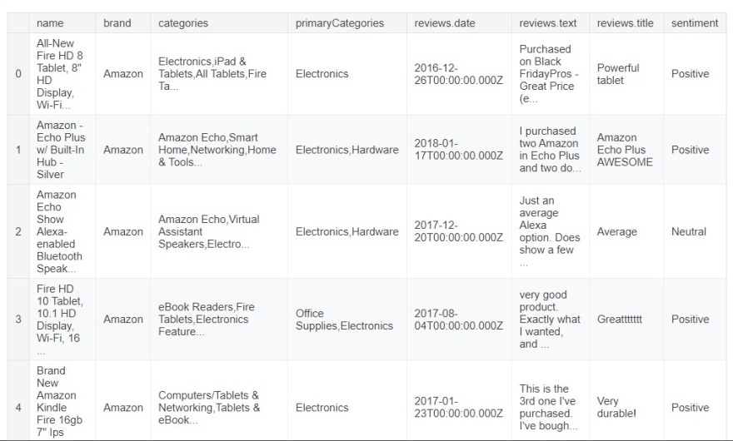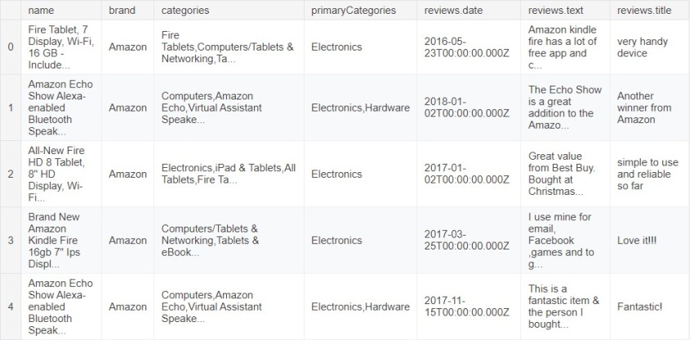

|  |  |
| --- | --- |
| **name** | **4000** |
| **brand** | **4000** |
| **categories** | **4000** |
| **primaryCategories** | **4000** |
| **reviews.date** | **4000** |
| **reviews.text** | **4000** |
| **reviews.title** | **3990** |
| **sentiment**  **dtype: int64** | **4000** |
| **58** |  |
| **name** | **1000** |
| **brand** | **1000** |
| **categories** | **1000** |
| **primaryCategories** | **1000** |
| **reviews.date** | **1000** |
| **reviews.text** | **1000** |
| **reviews.title**  **dtype: int64** | **997** |

**<class 'pandas.core.frame.DataFrame'> name object brand object**

**categories object primaryCategories object reviews.date object**

**reviews.text object**

**reviews.title object**

**sentiment object dtype: object**

**RangeIndex: 3942 entries, 0 to 3941 Data columns (total 8 columns):**

**name 3942 non-null object**

**brand 3942 non-null object**

**categories 3942 non-null object primaryCategories 3942 non-null object reviews.date 3942 non-null object**

**reviews.text 3942 non-null object reviews.title 3932 non-null object sentiment 3942 non-null object dtypes: object(8)**

**memory usage: 246.5+ KB**

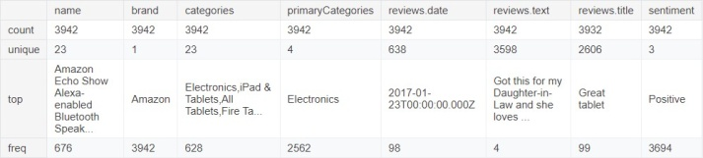

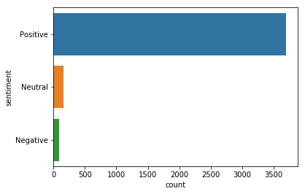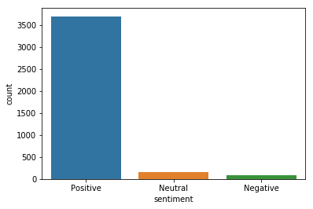

|  |  |
| --- | --- |
| **Positive** | **3694** |
| **Neutral** | **158** |
| **Negative** | **90** |

**Name: sentiment, dtype: int64**

|  |  |  |
| --- | --- | --- |
| **name** |  | **0** |
| **brand** |  | **0** |
| **categories** |  | **0** |
| **primaryCategories** |  | **0** |
| **reviews.date** |  | **0** |
| **reviews.text** |  | **0** |
| **reviews.title** |  | **10** |
| **sentiment** |  | **0** |
| **dtype: int64** |  |  |
| **name** | **0** |  |
| **brand** | **0** |  |
| **categories** | **0** |  |
| **primaryCategories** | **0** |  |
| **reviews.date** | **0** |  |
| **reviews.text** | **0** |  |
| **reviews.title**  **dtype: int64** | **3** |  |

**Index(['name', 'brand', 'categories', 'primaryCategories', 'reviews.date', 'reviews.text', 'reviews.title', 'sentiment'],**

**dtype='object')**

**Index(['name', 'brand', 'categories', 'primaryCategories', 'reviews_date', 'reviews_text', 'reviews_title', 'sentiment'],**

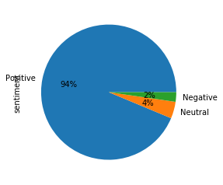**dtype='object')**

**Positive words**



**Negative words**

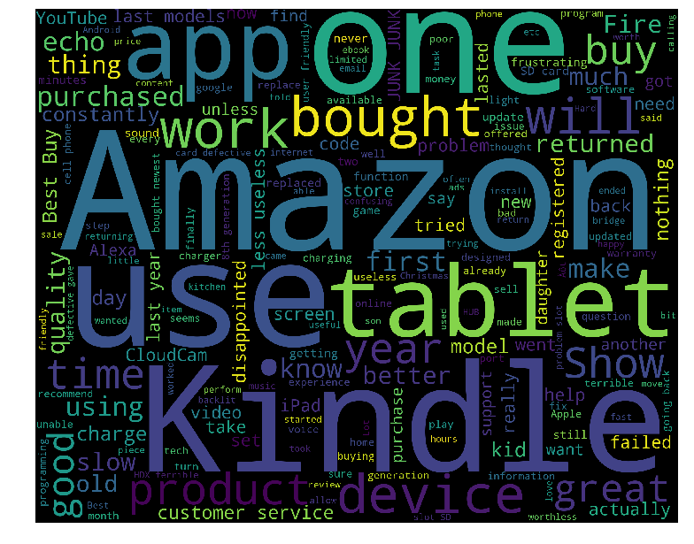

1. **[Purchased, on, Black, FridayPros, -, Great, P...**
2. **[I, purchased, two, Amazon, in, Echo, Plus, an...**
3. **[very, good, product, ., Exactly, what, I, wan...**
4. **[This, is, the, 3rd, one, I, 've, purchased, ....**
5. **[This, is, a, great, product, ., Light, weight...**

**Name: reviews_text, dtype: object**

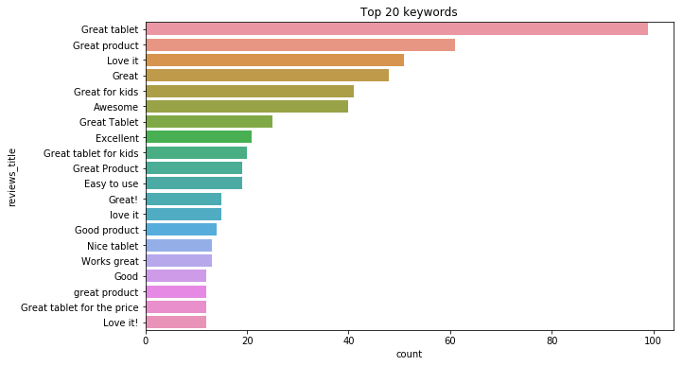

## CHAPTER-9

## SUMMARY

Stock prediction system using machine learning leverages historical market data, financial indicators, and sentiment analysis to forecast stock prices and trends, helping investors and traders make informed decisions. The system first collects data from stock exchanges, financial news, company reports, and social media. For real-time predictions, continuous data feeds from sources like Bloomberg or Yahoo Finance are crucial. The collected data is then stored in a structured database, ensuring scalability and supporting high-frequency trading contexts.

Once collected, the data undergoes preprocessing to ensure consistency and quality. This involves handling missing values, removing outliers, and normalizing values, which is essential for producing reliable predictions. The system generates relevant features such as technical indicators (e.g., moving averages, RSI), lagged variables, and sentiment scores derived from financial news and social media.

The model is trained using time-series forecasting techniques like ARIMA, LSTM networks, and GRUs to handle complex temporal patterns in stock data. After training, evaluation metrics like Mean Absolute Error (MAE), Mean Squared Error (MSE), and directional accuracy assess its predictive performance. A user-friendly dashboard displays essential metrics such as stock trends, trading volumes, and prediction confidence levels, making it easy for users to interpret data. Real-time monitoring allows users to view ongoing trends, while customizable filters provide focused analysis on specific stocks or periods, catering to both daily traders and long-term investors.

Data export options enable users to download reports in formats like CSV, Excel, or PDF. Regular model maintenance ensures the system adapts to changing market conditions through periodic retraining, automated pipelines, and version control. With strict data security measures and compliance with financial regulations, this comprehensive stock prediction system supports diverse trading strategies, from short-term, high-frequency trading to long-term investment planning.

## CHAPTER-10 REFERENCE

**Zhang, G., & Zheng, Y. (2020).**

**Title:** Stock Market Prediction Based on LSTM Neural Network and Attention Mechanism.  
**Publisher:** Journal of Computational and Applied Mathematics.  
**Publisher Location**: Elsevier.

**Fischer, T., & Krauss, C. (2018).**

**Title:** Deep Learning with Long Short-Term Memory Networks for Financial Market Prediction.  
**Publisher:** European Journal of Operational Research.**Publisher Location:** Elsevier.

**Nguyen, T. T., & Nguyen, L. M. (2021).**

**Title:**Stock Price Prediction Using Machine Learning Algorithms: A Survey  
**Publisher:** Procedia Computer Science.  
**Publisher Location:** Elsevier.

• **Chen, J., & Hao, Z. (2020).**

**Title:** Predicting Stock Market Returns with Deep Learning: A Comparative Study of LSTM and CNN.  
**Publisher:** Proceedings of the 2020 IEEE International Conference on Data Science and Advanced Analytics.**Publisher Location:** IEEE.